Jesus Says - The Beatitudes
Bible Passage - Matthew 5: 1-12

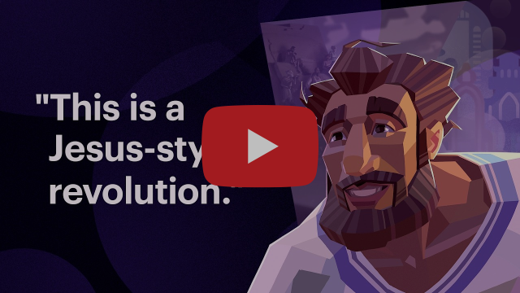

You can view this video and get a guide to the Beatitudes at https://bibleproject.com/guides/the-beatitudes/

Questions

- How is the Jesus-style revolution described in Matthew different from most revolutions?
- How are Jesus’ followers similar to Israel’s prophets? What kinds of attitudes and actions do they share?
- Do you particularly identify with any of the things that Jesus calls blessed?
- What would hunger and thirsting for righteousness, or making peace, look like on your frontline or with your community?

Jesus Says - Salt, Light and Law
Bible Passage – Matthew 5: 13-20

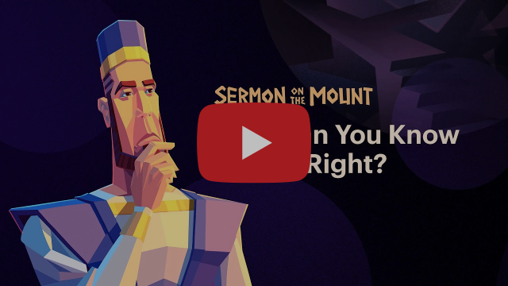

You can view this video and get a guide to this part of the Sermon on the Mount at https://bibleproject.com/guides/jesus-and-the-torah/

Questions

- How is the video’s description of righteousness similar to
or different from the way you’ve typically understood it?

- What do you think it means to be ‘the salt of the earth?”

- How might Jesus’ first audience have understood his claim that he was going to fulfil the story of the Hebrew Bible?

- What kinds of attitudes or actions could be seen as "doing right by your neighbour" for Jesus followers today?

- How might this work out in your everyday life or as a community?
Jesus Says – You have heard it said…
Murder, Adultery, Divorce.



You can view this video and get a guide to the passage at bibleproject.com/explore/video/wisdom-underneath-laws/

Questions

- Why does Jesus connect anger and name-calling to murder?
- How is looking at someone lustfully rooted in the same attitude as adultery?
- What might Jesus mean when he says to “cut off your hand” and “pluck out your eye”?
- When talking about divorce and remarriage, how is Jesus advocating for the fair treatment of women?
- What might healthier relationships look like in our lives and communities?

Jesus Says – You have heard it said…
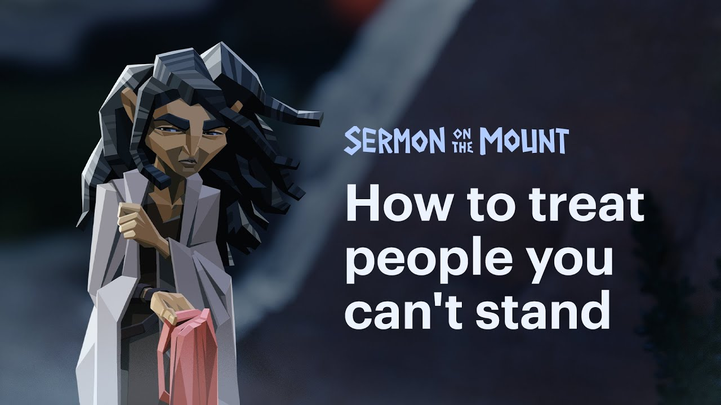
Oaths, Revenge and Enemies

You can view this video and get a guide to the passage at https://bibleproject.com/explore/video/wisdom-within-laws-about-oaths-retaliation-and-enemy-love/

Questions

1. How can I let my 'yes' mean 'yes' and my 'no' mean 'no'?
Are there any areas where I need to clarify and simplify my language in order to be a person of integrity?

2. Are there any areas of life where my humanity is being ignored? What would a creative response look like?

3. Are there any areas where I am ignoring the humanity of others? What practical changes do I need to make?

4. Are there any people or groups who are beyond the reach of my empathy? This could be people who vote differently from me or hold opinions about issues which are important to me. What could I do to understand them better? What would it look like to love them generously?
Jesus Says – When you practice – Giving, praying and fasting.

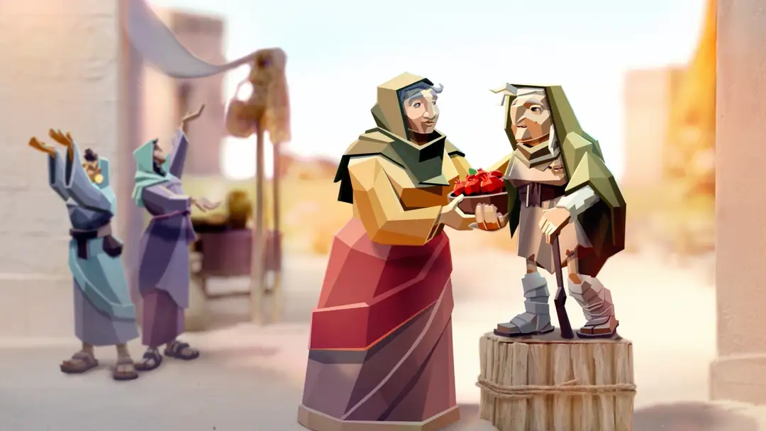

You can view this video and get a guide to the passage at https://bibleproject.com/videos/warnings-about-religious-practices

Questions

- What does Jesus opening “When you fast, pray, give…” stir up in you?

- What practices work for you, what ways has God given you to draw near?

- In Jesus’ day, what did it mean to be a hypocrite?
How is this the same or different from what a hypocrite is today?

- Why does Jesus encourage private generosity and secret prayer?

- What might you start, stop, try or develop as a result of this theme?

BONUS CONTENT – Practices!
Bonus Content – Practicing Jesus’ Way

Have you tried fasting, praying, giving. In what ways are they part of your practice?

Fasting – this could be going without food for a set amount of time (sunrise to sunset is a good mid-range start or simply miss lunch to pray). Or giving up something else you enjoy to make space and sharpen focus: might God call you to fast screen time, alcohol, a particular show or something else?

Praying – fixing regular time to pray is a great start here. Morning, midday or evening is the pattern many Christians have held over the centuries. Lectio 365 www.24-7prayer.com/resource/lectio-365 has short, led prayer for these 3 times. If you are starting from standstill perhaps just pick one of these, once you have given something a try you can tweak, develop, and enjoy discovering how you like to pray!

At Kairos we gather for 9:30am prayers Mon – Thursday and we pause to pray the Lord’s Prayer at midday.

Giving – again just giving this a go is a great way to start. Getting a regular, habitual (and secret) pattern of giving is good. Sometimes it’s also good to go on bigger journeys of generosity. I’ve enjoyed giving silly amounts and seeing God’s generosity multiply. For that kind of giving, it’s definitely a good idea to do some process with a trusted friend before acting.

Want more on Practices? John Mark Comer’s Practicing the Way is a great starting point. There’s a book and loads of other resources at https://www.practicingtheway.org

Jesus Says – The Lord’s Prayer



You can view this video and get a guide to the passage at https://bibleproject.com/videos/lords-prayer

Questions

- Why does Jesus tell his followers to address God as “our Father”?
- Why would someone pray for God’s name to be recognized as holy?
- When Jesus prays, "Your Kingdom come, and your will be done," what is he asking for?
- What does praying “give us today our daily bread” remind us about in the Old Testament, and what might it instil within us?
- Why does Jesus so closely connect God’s forgiveness of us to our forgiveness of others?
- Jesus prays about temptation, or “testing,” and then prays about deliverance from the evil one. How do these concepts or ideas relate?

Pausing to Pray

Join with others in Kairos pausing to say the Lord’s Prayer at midday (or a time close to that that works – like just before lunch.) Try saying the prayer out loud slowly, notice if any phrase draws your attention and pray a little about that.

If you want a slightly more led time of prayer, try Lectio 365’s midday prayer.

Jesus Says – Wealth and Worry


You can view this video and get a guide to the passage at https://bibleproject.com/videos/wealth-and-worry

Questions

- We say we trust in God; can you think of a time when you trusted God for something you needed and He met that need?
- Can you think of something practical you can do with money that helps put focus on God and what's important to him?
- Can you think of a time when you gave generously because God had shown you a need?
- What do you need God's power for?
- How do you share what you have with others? (time, home, resources, stuff)
- How would you know if God is asking you to give something you have away?
- What do you worry about/are you concerned about?
- Do you feel you could ask God to give your mind peace?
- Have you tried centring prayer?

Find out more about this way of prayer at: https://downloads.24-7prayer.com/prayer_course/2019/resources/pdfs/4%20%282%29%20Breath%20Prayer.pdf

Jesus Says – Wisdom in Relationships
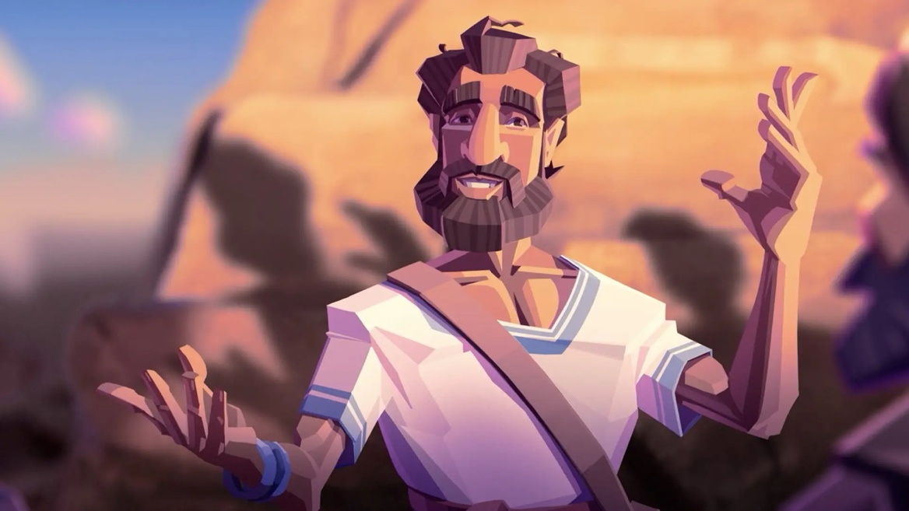

You can view this video and get a guide to the passage at https://bibleproject.com/videos/wisdom-in-relationships

- In this section of teaching, what kind of trap is Jesus warning his followers about?
- When we feel the desire to judge others, what two things does Jesus encourage us to do instead? (See Matthew 7:1-5.)
- Jesus advises people not to cast “pearls in front of pigs.” How would you describe the wisdom he’s communicating through that metaphor?
- Matthew 7:7-8 is sometimes used to support the idea that God gives people anything and everything they ask for. But in the larger context of Matthew 7:1-2, how might we interpret his words?
- In Matthew 5:17 and Matthew 7:12, notice the repeated phrase “the Torah and the Prophets.” What might these two bookend verses tell us about Jesus’ message in this section?
- Reflect on any other themes or topics that came up after watching the video. Jesus’ Golden Rule is a simple yet challenging way to live. What kinds of situations would make it most difficult to follow Jesus’ instruction?

Jesus Says – The Choice

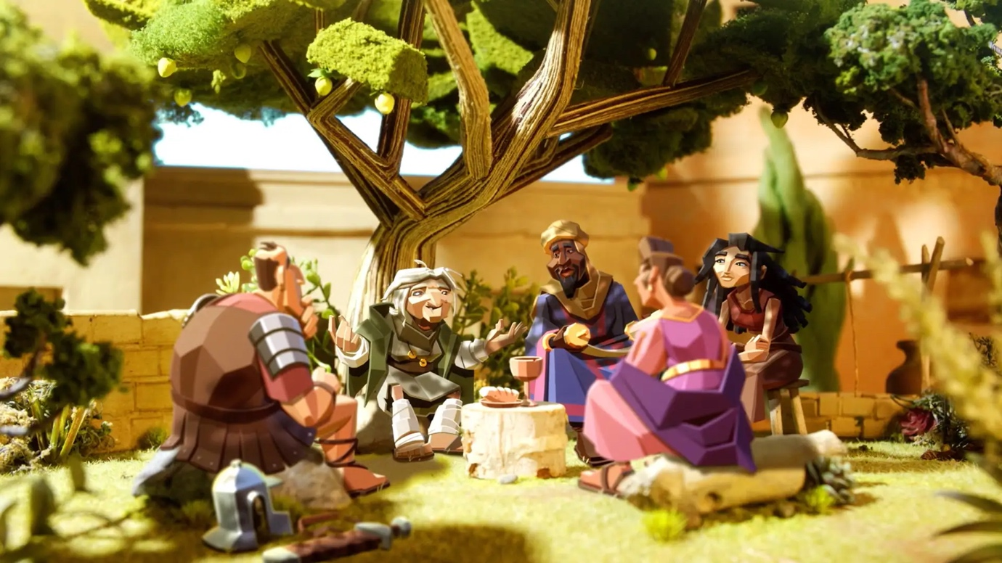

You can view this video and get a guide to the passage at https://bibleproject.com/videos/the-choice

Questions

- The beginning of this video frames the story of the Bible as a choice between two paths—one leading to life and the other to death. How does this reframe impact your understanding of the Bible?
- According to Jesus, why does the path leading to life often feel narrow or constricting?
- Jesus says that we can identify illegitimate prophets by their fruit. What are some examples of bad fruit produced by a leader? What are examples of good fruit?
- How is it that people can do things in Jesus’ name but not actually be known by him?
- Why does Jesus compare our choices and lifestyle with building a house? How does this connect to the concept of Israel’s temple as “the house of God”?
- Jesus says that the wise person who builds on the rock hears his words “and does them.” Why is it important to trust in Jesus and to follow his way of life?
- How can following the teachings of Jesus in the Sermon on the Mount prepare us for the storms of life?

Bonus Content – Practices for the Narrow Path.

Rich Villodas’ The Narrow Path (www.eden.co.uk/christian-books/spiritual-growth/discipleship/the-narrow-path) is a brilliant introduction to the sermon on the mount and finishes with 6 practices to live out Jesus’ teaching. They are:

#1 Meditate on Jesus’ Teachings
Try to read the sermon on the mount regularly (once or twice a month)
Pray through the beatitudes

#2 Hunger and Thirst for Righteousness
Reflect on your current ways of living and seek to make changes that help you
live more in line with Jesus teaching. This might look like – volunteering
somewhere, joining a community or choosing to see something you already do
in a new way.
#3 Speak Truthfully
Resist the temptation to spin things or being deliberately vague or untruthful.
Embrace honesty in your relationships.

#4 Pray for enemies
Name before God the people you have a hard time loving, pray for good and
blessing in their life as often as you can.

#5 Offer silent generosity
Find ways to practice anonymous giving.
Seek to take increasing steps of generosity as God leads you.

#6 Surrender Anxiety
Notice when fear or worry is pre-occupying you.
Pause, breathe deeply, offer those things to God,
Ask him to guide, protect and shield you.

Hear him talk about the book on the renovare podcast here: https://renovare.org/podcasts/lifewithgod/rich-villodas-the-narrow-path

